Meeting Agenda/Minutes - MO.DAY.YEAR

Chapter Meeting Agenda & Minutes Template
Please use this template to document all official chapter meetings.

Before You Begin
This is a view-only master template. Please do not request editing access or make changes to the original document.
To use this template:
- Select File → Make a copy.
- Save the copy in your chapter’s designated Google Drive folder.
- Rename the document using the required naming convention below.
- Complete the agenda before the meeting.
- Record meeting notes, motions, decisions, and action items during the meeting.
- Rename the completed document as the official meeting minutes.

Required File Names

Before the Meeting
[Chapter Name] Chapter Meeting Agenda – MM.DD.YYYY
Example:
Founding Chapter Meeting Agenda – 09.15.2026

After the Meeting
[Chapter Name] Chapter Meeting Minutes – MM.DD.YYYY
Example:
Founding Chapter Meeting Minutes – 09.15.2026
The same document should be used for both the agenda and the minutes. After the meeting, update the document with the official meeting record and change “Agenda” to “Minutes” in the file name.

Distribution Expectations
- The Communications officer should distribute the meeting agenda at least 48 hours before the meeting. Earlier distribution is strongly encouraged.
- Completed meeting minutes should be distributed no later than 48 hours after the meeting.

Chapters may prepare meeting agenda documents for the entire quarter or semester in advance. Editing access may remain restricted until each agenda is ready to be completed.

If the chapter is on Probation or Suspension, the meeting minutes must also be sent to the National Board at National.Sunnies@gmail.com.
Email: Attn: ___ Chapter Minutes (mo.da.yr)

Meeting agendas and minutes are official chapter records. Use professional language, accurate information, and clear documentation throughout this document.

CHAPTER TEMPLATE
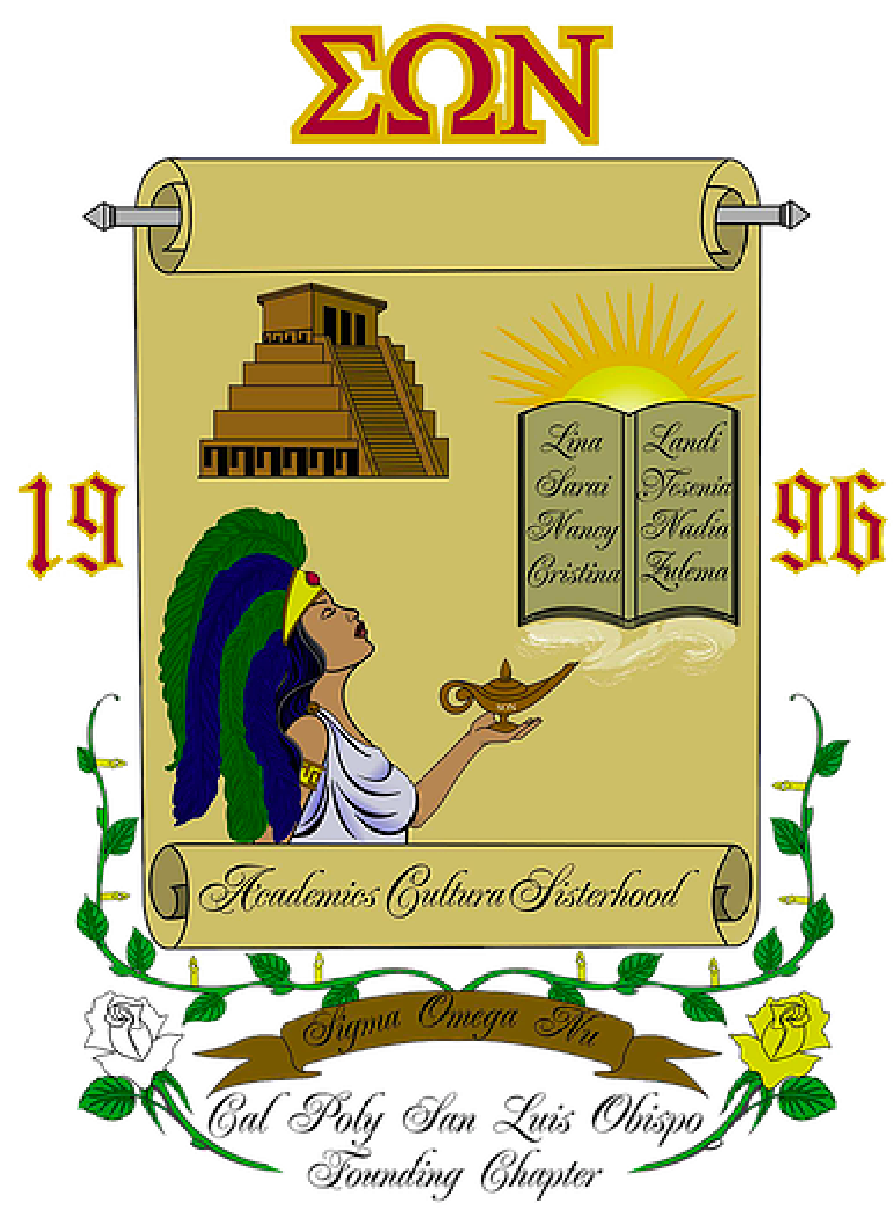
Sigma Omega Nu
Latina Interest Sorority, Inc.

___ Chapter Meeting
Date
Time

Meeting Called to Order:
Founder’s Chant: Academics, cultura, and sisterhood are the things we hold true and we shall remain faithful to the letter of Sigma Omega Nu. The sun, a symbol of our existence. White and yellow roses, the sign of pure friendship. Black, burgundy, and gold, the colors we represent which tell our story. For all the struggles we may face,together we will live, learn, and celebrate that which unites us as hermanas.
Officers:
Attendees:
Absent:
Other Attendees:
Total Members: ___ Quorum Eligible: ___ Quorum Required: ___ Members in Attendance:
Approval of Meeting Minutes: Date Motion: Second: Vote:
Approval of Meeting Agenda: Date Motion: Second: Vote:
- Officer Reports
  - President (Name)

  - Vice President (Name)

  - Sergeant-at-Arms (Name)

  - Treasurer (Name)
    - Chapter Balance:

  - Vice President of Communications (Name)

  - Auditor (Name)

  - Risk Management (Name)

  - Commissioner of Cultura and Sisterhood (Name)

  - Commissioner of Community Service (Name)

  - Commissioner of Fundraising (Name)

  - Commissioner of Alumnae Relations (Name)

  - Commissioner of Social Affairs (Name)

  - Commissioner of Public Relations (Name)

  - Historian (Name)

  - Pledge Mother(s) (Name)

  - University Representative (Name)

  - National Board Representative (Name)

- Old Business

- New Business:

- Announcements:

- Adjournment:

  - Next Meeting:
  - Upcoming Events & Deadlines

